* Chỉ áp dụng được với parameter bình thường
  + **Setup**

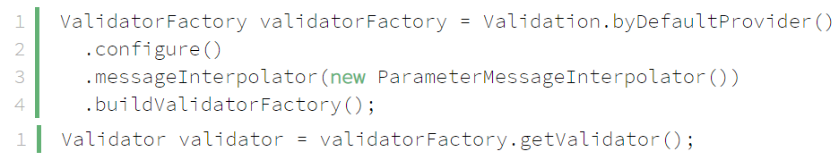

*configure ValidatorFactory*

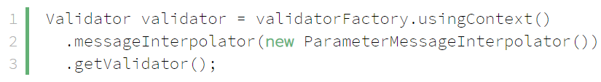

*Configure Validator*

* + **Validation**
    - **{***AttributeName***}**

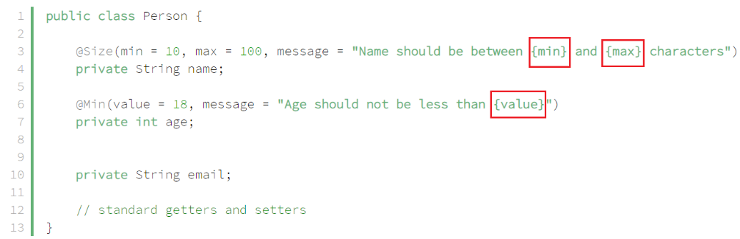

* + - *${*validatedValue*}*

*là trỏ tới property, bean, method parameter*

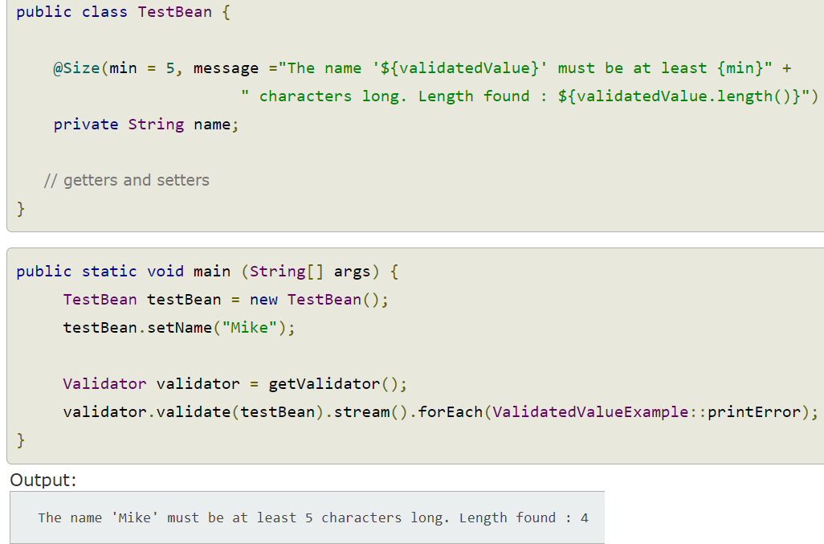

* + - **Characters**

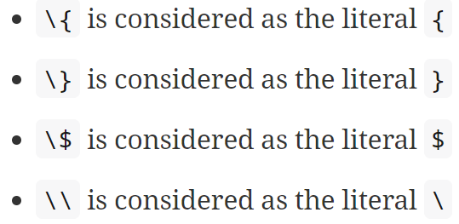

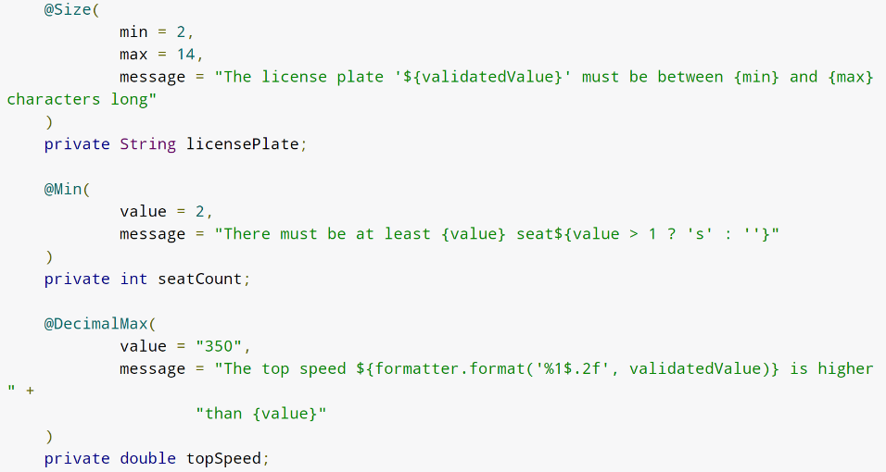

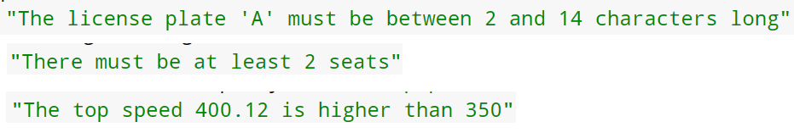

* + **Test**

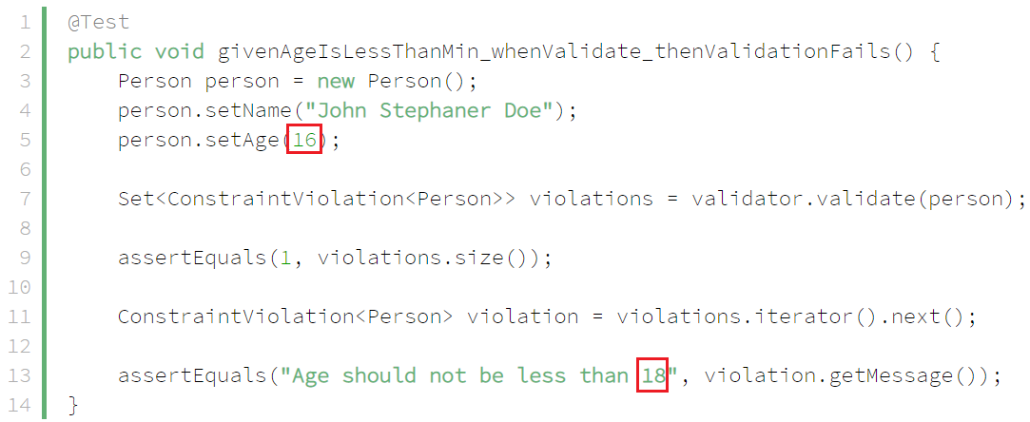

* **Reference**

<https://www.baeldung.com/hibernate-parametermessageinterpolator><https://docs.jboss.org/hibernate/stable/validator/reference/en-US/html_single/#chapter-message-interpolation>